CRM Project

Functional Specification - Enhancement

PP6_Contract Management Cancel New Contract

CM_090-160-080-E
(CM_ENH_220)

Deliverable Name | CM_ENH_220
Date | 11/10/2010
Revision | V1.0
Signed off By | Functional lead/PP6 Owner
Signoff Date

TABLE OF CONTENTS

1. Version 3
2. Approvals 3
3. Priority Mention the Priority of the object from the FRICEW list in ILM. Processing Mode (check all that apply) 4
Low Medium High 4
4. Enhancement Requirements Description 4
5. Impacted Systems 4
6. Approach to be followed 4
7. Roles and Volumes 4
8. Security & Control Requirements 5
8.1 Security Requirements 5
8.2 Control/Audit Requirements 5
9. Dependencies 6
9.1 Development Dependencies 6
9.2 Run/Execution Dependencies 6
9.3 Archiving Dependencies 6
10. Execution Steps 6
10.1 Process Description 6
10.2 Process Flow 6
10.3 As-Is Systems Referred To 7
10.4 Processing Options 7
11. Enhancement Description 7
11.1 Detailed Description of the Enhancement 8
11.2 UI Design and Screen Flow 11
11.3 Access Method or Path for Enhancement 12
11.4 Required Custom Tables (if known) 12
11.5 Error Handling Rules 12
12. Enhancement Reconciliation & Testing Requirements 13
12.1 Data Validation 13
12.2 Testing Reconciliation 13
12.3 Performance Issues 13
13. Additional Information 13
14. Open Items 13
15. Functional Unit Test cases 13

Version
Ensure that any approved change requests that affect scope are documented in the revision history and include CR #.
Version | Change Description | Author | Date Released | Sections Impacted
Enter in the version number | Brief description of the change | Who made the change | Date change was made | Mention the sections impacted with this change
1.0 | Document Creation | Ronda Clandening | 11/10/2011
1.3 | Changes per feedback from development | Ronda Clandening | 1/21/2011 | Added process code, added to dependency field, added to expected results field.
2.0 | Update Interaction Record verbiage - Item 6, page 12  Deleted New Contract Notification logic. Left order codes created in New Contract process – Item 5, page 10 | Judy Jarone | 2/16/2011 | Section 11.1
3.0 | Added priority 4 to Interaction Record | Ronda Clandening | 3/14/2011 | Section 11.1, #7
3.1 | Change Request CHG03955 Restrict the Cancel Notification candidates to Notification Types of D2 and D3  Change Request CHG03962  Notification Cancellation Error handling | JJarone | 5/18/2011 | Section 11.1, Item #5.

Approvals
The individuals listed below will be required to review and approve this document.
Reviewers Title | Reviewer Role | Name
Technical Team Lead | Approve | V. Krishna Karunakaram
CRM Functional Team Lead | Approve | Robert Smeltekop
Business Owner | Approve | Anita Jackson
Business Owner | Approve | Diane Couture
Business Owner | Approve | Corey Williams

Priority
Mention the Priority of the object from the FRICEW list in ILM.
Processing Mode (check all that apply)

Low Medium High

NA

Enhancement Requirements Description

Since the CRM 7.0 Cancel New Contract does not meet today’s requirements, it will have to be adjusted. The process ID is CONTSTART_CANCEL.

The Cancel Contract (Reversal) will be used when a request is made to reverse a Move In or Move Out. The system will determine which processing option is allowed based upon the population of the Contract’s Start Date or End Date. If the contract’s end date is not populated then the cancel of the New Contract will be allowed.

The user will select Cancel Contract from the Contract Management Work Center sub menu Cancel Contract to start the process.

This document will pertain to the Cancel New Contract (Reverse Move In) process.

Impacted Systems

CRM 7.0 Web IC : CRM 7.0 Web Client Interaction Center Production System
ECC 6.0 / IS-U ECC 6.0 / IS-U : Back End Production System (Enterprise Central Component)

Approach to be followed
An enhancement will be required to validate the cancel (reverse) New Contract and cancel (reverse) of the Forced End Contract.

Roles and Volumes
In terms of volume, this is a medium frequency process that could be performed many times in a day by several of the business roles.

Role | Estimated Volume Requirement | Comments
List name of role; should come from the list of security roles | Enter the estimated volume requirements that will be needed by the Go-Live date | Enter other comments including if this development will require additional communication and/or training
CSR 2 | 1000 times per day
CSR 3 | 1000 times per day
CSR 4 | 25+ times per day
VCC MGMT | 25+ times per day
BCOS | 15-20 times per day
Billing | **times per day
Consumer Affairs | **times per day
Revenue Recovery | **times per day
Gas Trans | **times per day

Security & Control Requirements

Security Requirements
This enhancement will be available to the following business roles:

CSR 2
CSR 3
CSR 4
VCC MGMT
BCOS
Billing
Consumer Affairs
Revenue Recovery
Gas Trans

Control/Audit Requirements
<Describe any control requirements that need to be put in place as a result of this development object>.
- If applicable, please answer the question and also provide detail to the question.
- The questions listed below are not all inclusive to the control requirement that may be required. If there are any other controls requirements please document them as well.

- Indicate if this enhancement is being developed to address a control requirement?
- Financial/SOX Impact - Does the enhancement have any impact to financial reporting? If yes, is the amount significant (i.e. greater than $35 million annually)? Please provide an estimate.
- Regulatory Impact - Does the enhancement have any impact to regulatory compliance (i.e. FERC, NERC, etc)? If yes, please provide a reference to the rule and describe the impact.
- Operational Impact - Is the enhancement relied upon for a mission critical process or providing services to customers? If yes, please identify the mission critical process and describe how this enhancement is used in the context of this process.

CRM_041

Dependencies

Development Dependencies
This is dependent on New Contract creation being complete: CM-090-090

This is dependent on CM-090-090-075-E.CM_ENH_350 (Notification View), which is dependent on CM-060-0230-020-E SO_ENH_050 Maintain Orders and Notifications

The notification view PP6 has the notification types.

Run/Execution Dependencies
Business Partner and Premise must be confirmed.

Archiving Dependencies
- Not Applicable

Execution Steps

Process Description
This process may be accessed in 2 ways:
- A user may click directly on Contract Management Work Center
- A user may select the dropdown from Contract Management Work Center, and then select the sub menu Cancel Contract (This will be the Best Practice method)

Process Flow
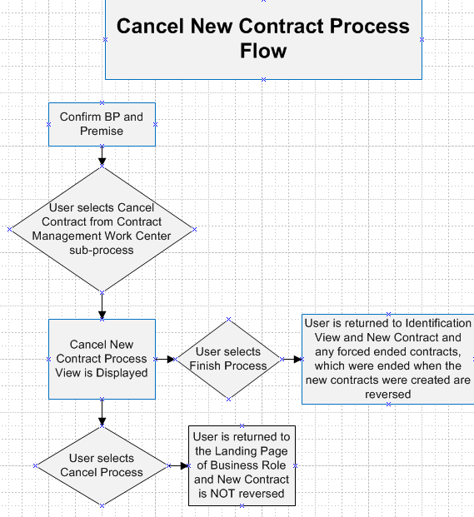

As-Is Systems Referred To
CRM 5.0 Win IC : Win Client Interaction Center - Production System
ECC 6.0 / IS-U ECC 6.0 / IS-U : Back End Production System (Enterprise Central Component)

Processing Options
Processing Mode (Select one of the following)
Batch Online – via Transaction Code Online – via Menu Path
On demand

Frequency (Select one of the following)
Daily
Weekly Quarterly
Monthly Annually
Other (If other, describe here)

Lifetime of Development (select one)
Permanent
Temporary, e.g. until rollouts are complete, specify details here

Enhancement Description
An enhancement will be required to validate the cancel (reverse) New Contract and cancel (reverse) of the Forced End Contract.

Detailed Description of the Enhancement
Selection of Cancel New Contract Process

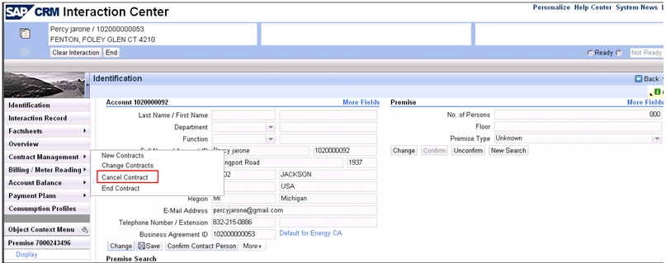

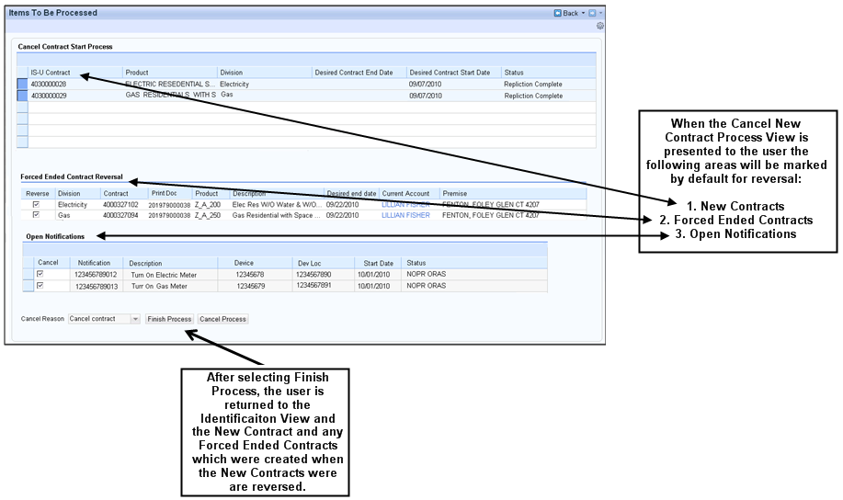

There will be times when a user may have to cancel (reverse) a New Contract. These are the steps that will be performed by the user for Cancelling the New Contract in CRM 7.0:

- User selects Cancel Contract from the Contract Management sub menu
- Cancel New Contract Process View is displayed
- User selects ‘Finish Process’ (if error, user will receive message and select ‘Cancel Process’, and be given standard “Are you sure you want to cancel” pop up)
- Identification View is displayed
- END

These are the steps the system will have to perform before the user selects ‘Finish Process’ in order for the user’s process to be successful:
- The custom method ZMOVINDOC. Cancelwitherrormsg was created because the standard method MOVEINDO.CANCEL did not capture any errors returned. So we will need a method to capture any errors returned. If the method identifies an error was returned, then the user will receive a system message (see details of message in section 11.5 number 1.1). The user will then be required to manually investigate and resolve the error in order to successfully reverse the New Contract.
- If no error was returned the New Contract will need to successfully reverse.
- A check will need to be done to see if the previous Move Out was forced.
- If the Move Out was forced the Forced Ended Contract Reversal indicator will be marked by default, and the user will be unable to de-select the ‘Reversal’ indicator. If the account has final billed, the invoice and billing document will be reversed prior to the cancellation of the Force Ended Contract.
- If the previous forced End Contract is reversed, then the corresponding End Contract service notifications (only notification types of D23 and D3 are applicable for cancellation) for the device locations) are processed (cancelled) in the background, however the user is able to edit.

In case cancellation of a notification fails a warning system message "Cancellation of Notification & Failed." should be displayed for each failed contract to let the user know. Also, the following should be written to the IR for each failed record:
App ID: CM_CNS_NOTI_FAILURE
Message: Cancellation of Notification & Failed.

Listed below are all the possible order codes for the New Contract Notification process.

Order Code | Description
ZINE | INSTALL ELECTRIC METER
ZING | INSTALL GAS METER
ZREE | READ ELECTRIC METER
ZREG | READ GAS METER
ZRIE | REINSTALL ELECTRIC METER
ZRIG | REINSTALL GAS METER
ZAEP | TURN ON / ELE OFF AT POLE SNP
ZAEW | TURN ON / ELE OFF AT W HEAD SNP
ZAGC | TURN ON / GAS OFF AT C BOX SNP
ZAGP | TURN ON/GAS MTR CUT/CAPPED SNP
ZDNE | TURN ON / GAS OFF AT METER SNP
ZDNG | TURN ON / ELE OFF AT METER SNP
ZGEP | HARDSHIP ON / ELE OFF AT POLE
ZGEW | HARDSHIP ON/ ELE OFF AT W HEAD
ZGGB | HARDSHIP ON / GAS OFF AT C BOX
ZGGC | HARDSHIP ON/GAS MTR CUT/CAPPED
ZREP | TURN ON / ELE OFF AT POLE
ZREW | TURN ON / ELE OFF AT W HEAD
ZRGC | TURN ON / GAS OFF AT C BOX
ZRGP | TURN ON/GAS MTR CUT/CAPPED
ZTHE | HARDSHIP TURNON ELECTRIC
ZTHG | HARDSHIP TURNON GAS
ZTNE | TURN ON/ ELECTRIC OFF AT METER
ZTNG | TURN ON / GAS OFF AT METER

- Interaction Record notes are written for the Cancelled New Contract (Move In Reversed) and Forced Ended Contract (Move Out Reversed).

Please refer to PP6 CRM.PP6.CM-080-100-010-E.FO ENH 3820 Automatically Log System Notes on Interaction Record for details on Interaction Record Notes
- Interaction Record Note– Write to the Interaction Record.
  - APP ID: CM_CNNC
  - Message: “Contract with start date &1 reversed
&1 = Contract start date

- Interaction Record Note– Create new Interaction Record for the Force Ending Contract being reversed. Create new interaction record with corresponding BP and Business Agreement
  - APP ID: CM_CNEC
  - Message: “Forced Ended Contract with end date &1 reversed”
&1 = Force contract end date.

&1 = Contract Start Date

The Move In Reversal workflow WS93000109 is triggered by the reversal of the of the Move In document (ie is event driven) and processes the associated Move In service orders, and reinstates the previous rate category.

- The Interaction Record will have a priority value of 4.

UI Design and Screen Flow
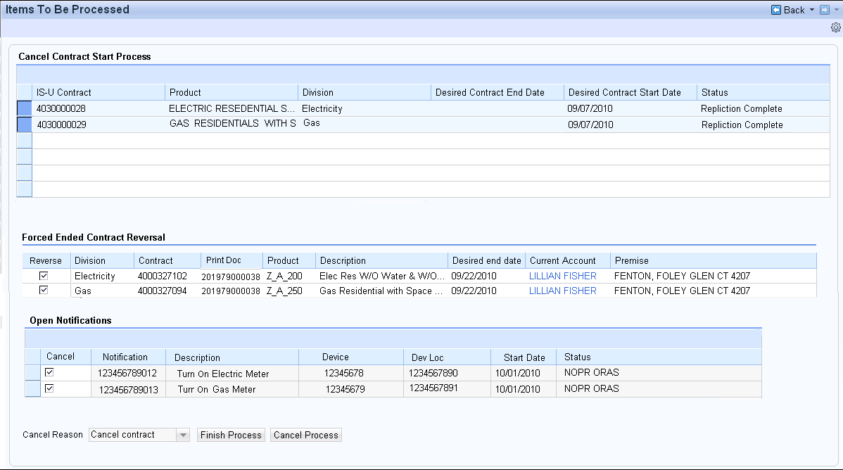

Access Method or Path for Enhancement
Execution: Custom Transaction Code:
Menu Path:
Standard Transaction Code:
Other: CRM 7.0 Web IC Navigation

Required Custom Tables (if known)
Table Name: NA
Table Description: NA
M/O | Field Description | Type (text or numeric) | Maximum Field Length | Value Restrictions? | Validations?
Mention M if the field is mandatory and O if the field is optional | Enter the field description | Enter the type | Enter the max. field length | Enter any value restrictions | Mention if any validations are required or else mention NA

Error Handling Rules

CRM 7.0 System Messages (Error if system unable to Reverse New Contract)
1.1 - “ All billing and/or payment documents must first be reversed”

The Cancel Contract (Reversal) will be used when a request is made to reverse a Move In or Move Out. The system will determine which processing option is allowed based upon the population of the Contract’s Start Date or End Date. If the contract’s end date is not populated then the cancel of the New Contract will be allowed.

Enhancement Reconciliation & Testing Requirements

Data Validation
- Data validation will require the expected test cases execution and verifying the results based on business requirements. CRM project team along with their business support teams will be responsible to ensure this enhancement works.

Testing Reconciliation
- This enhancement will be tested by the teams (their security roles) who perform the New Contract process. Teams will include CRM project team, BTS support team, Call Center, BCOS, Revenue Recovery, Consumer Affairs, and Billing.

Performance Issues
- NA

Additional Information
NA

Open Items
NA

Item # | Detailed Description | Proposed Solution
Insert number | Describe the item | Describe the proposed resolution
1.

Functional Unit Test cases
Test Condition Description | Input Data | Expected Results | Actual Results/Comments
Cancel New Contract – Account has not billed |  | New Contract is reversed
Cancel New Contract – Account has billed |  | New Contract is reversed and billing is reversed
Cancel New Contract – There is a New Contract present for a future date |  | Error message is received, “ All billing and/or payment documents must first be reversed”, It is up to the user to manually correct

